Goods are tangible items manufactured by businesses, such as laptops. ​

Services are intangible offerings of businesses that can’t be held, touched, or stored. Physicians, lawyers, hairstylists, car washes, and airlines all provide services.

A staple food, product, or activity is one that is basic and important in people's everyday lives. Rice is the staple food of more than half the world's population.

​

The **tools, machinery, equipment, and buildings** used to produce goods and services and get them to the consumer are known as capital.

**Revenue** is the money a company receives by providing services or selling goods to customers. ​

**Costs** are expenses for rent, salaries, supplies, transportation, and many other items that a company incurs from creating and selling goods and services.​

**Profit** = Revenue > Cost​

**Loss** = Cost > Revenue​

**Risk** is the potential to lose time and money or otherwise ​

not be able to accomplish an organization’s goals.

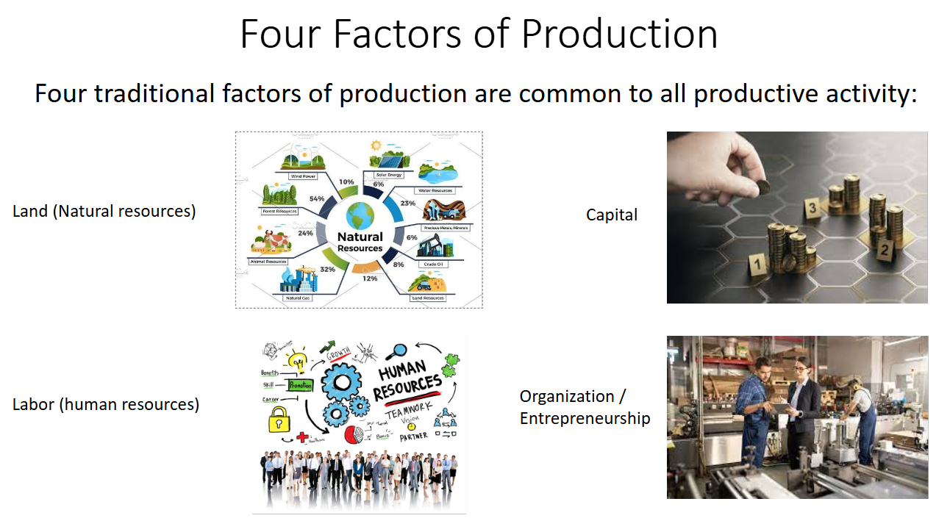

Trade The action of buying and selling goods and services.

**Trade** is referred to as a basic economic activity that involves buying and selling of different goods and services between two or more parties involved in the transaction. **Commerce** involves all the activities that aid in promoting the exchange of goods and services from the manufacturer to the last customers.​

A **business** is an organization that strives for a profit by providing goods and services desired by its customers.

**Entrepreneurs** are the people who combine the **inputs** of **natural resources**, **labor**, and **capital** to **produce** goods or services with the intention of **making a profit** or accomplishing a not-for-profit goal.

Management is a set of principles relating to the functions of planning, organizing, directing and controlling, and the application of these principles in harnessing physical, financial, human, and informational resources efficiently and effectively to achieve organizational goals.

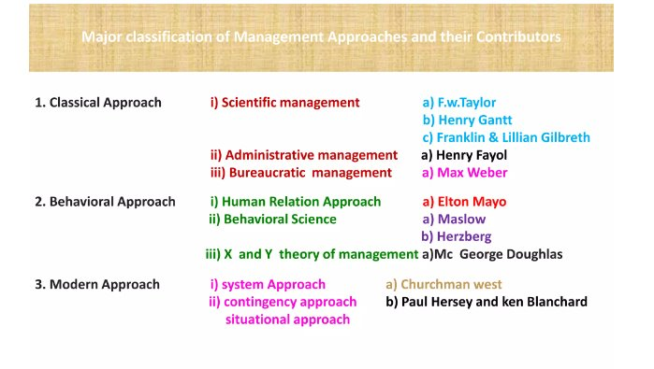

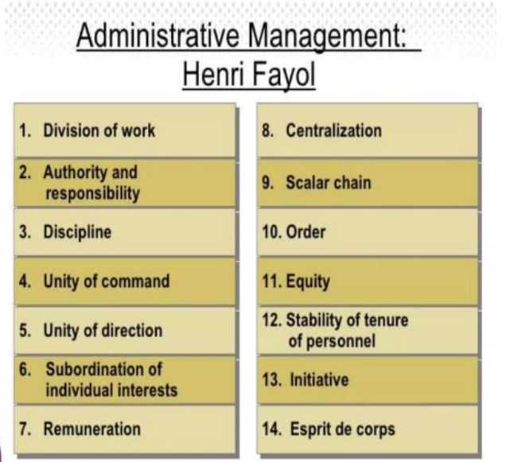

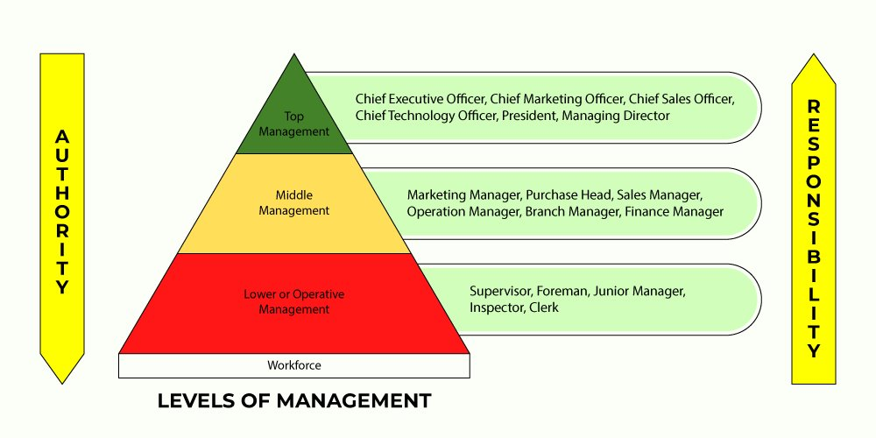

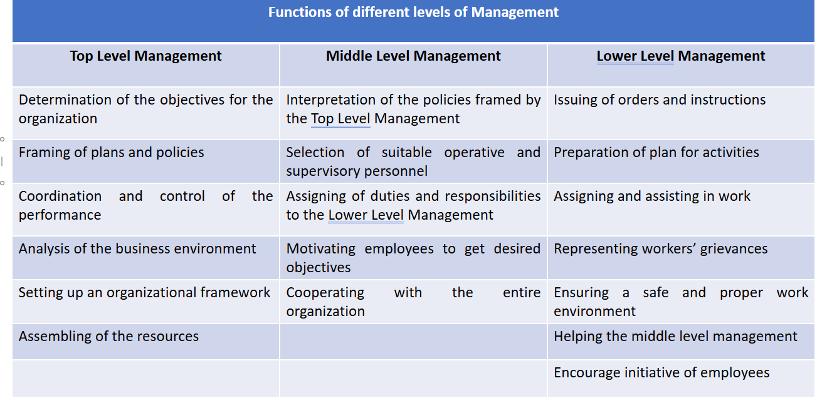

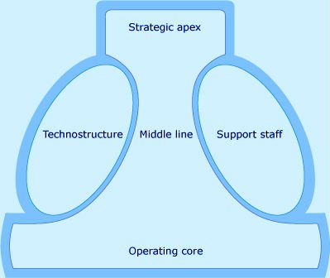

A functional structure groups employees into different departments by work specialization. Each department has a designated leader highly experienced in the job functions of each employee supervised by them.​

A divisional structure organizes employees around a common product or geographical location. ​

Divisional organizations have teams focused on a specific market or product line.​

Examples of companies applying a divisional structure are McDonald’s Corporation and Disney.​

Matrix Having multiple supervisors allows for company-wide interaction and faster project delivery.

For instance, when answering to functional managers and project managers, employees have a chance to collect experience outside their team. While functional managers can help to solve job-specific issues, project managers can bring in knowledge or talents from other departments.​

A team-based organizational structure creates small teams that focus on delivering one product or service. These teams are capable of solving problems and making decisions without bringing in third parties.​

A network structure goes far beyond your internal company structure. It’s an act of joining the efforts of two or more organizations with the goal of delivering one product or service. Typically, a network organization outsources independent contractors or vendors to complete the work.​

A chain of command, in this case, goes from senior management to general employees through a range of executives on the departmental and team level. ​

The highest-level executive has the highest power over the decision-making process.​

In a flat organizational structure, there are few middle managers between employees and top managers. The structure requires less supervision, increases employee involvement, and boosts trust in the workplace.​

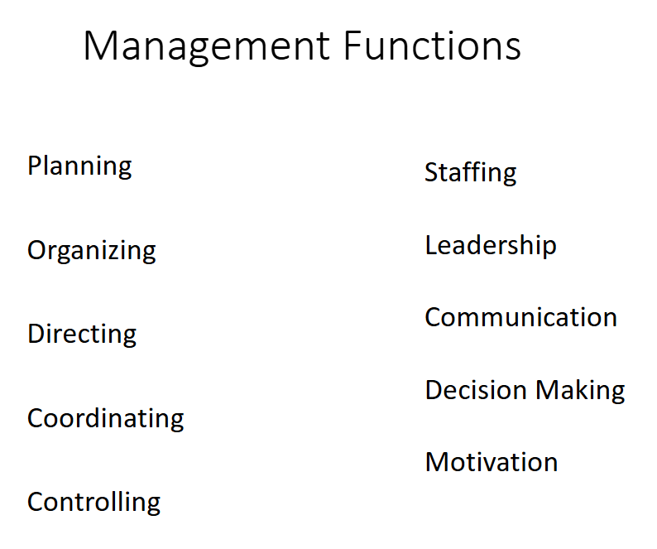

A Purpose Statement is an explanation of the company’s motivations and reasons for being, and why it works the way it does.​

A vision statement details where the organization aspires to go. A **vision is a more abstract idea of how the organization intends to impact society**.​

A mission statement defines the organization's business, its objectives, and how it will reach these objectives. A**company's mission defines its business goals and the values it will embrace to achieve them.**​

**The first is a statement of vision**. It provides a destination for the organization. Next is a statement of mission. This is a guiding light of how to get to the destination.​

Vision – **We believe that we are on the face of the earth to make great products, and that's not changing**.​

Mission – **Bringing the best user experience to its customers through innovative hardware, software and services.**​

​

**A goal is an achievable outcome that is generally broad and longer term while an objective is shorter term and defines measurable actions to achieve an overall goal**.​

Goals can be intangible and non-measurable, but objectives are defined in terms of tangible targets.

For example, **the goal to “provide excellent customer service” is intangible, but the objective to “reduce customer wait time to one minute” is tangible and helps in achieving the main goal.**​

**S.M.A.R.T.** is an acronym for:​

**S**pecific — Objectives have a high level of concreteness with real metrics and deadlines that need to be tracked. For example, “Generate 50 leads from the UK before 30 Oct” is more specific than “increase the international customer base.”​

**M**easurable — Make sure that you can track the success of your objective. What’s the key performance indicator (KPI) that you’re going to track? (Don't forget to identify the person responsible for tracking each objective.)​

**A**ttainable — An objective is challenging but possible. “Helping 10 million international businesses be more productive” is admirable but not very actionable if you have 100 customers. Don't try to conquer the world overnight.​

**R**elevant — Is the objective related to your long-term goal, and does it align with your company vision?​

**T**ime-bound — Your objective needs to have a concrete deadline (target date). “Someday” is not a day of the week.​

​

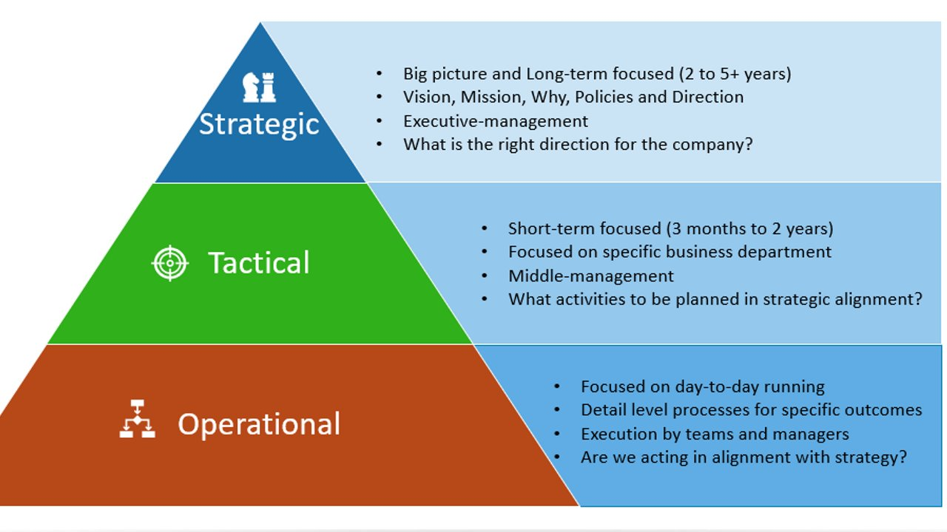

The strategy level is the big picture. It is long-term focused and a point where the executive management focuses on the vision and mission of an organization. ​

​

It could be a clearly spelled out two-year to Five-year vision for the company. The executives are most concerned and involved at this level a lot more. For IT professionals and IT Leaders, this helps to understand what direction the company is heading to and how the IT initiatives can support that path. ​

​

An important question for the leaders at this level is, "What is the right direction for the company?"​

​

**The tactical level** is for the mid-term. Depending on the company type, it can be planned for six months to two years on the time horizon. ​

​

It can be focused on specific business departments, unlike the strategic level of planning, which focuses on the entire company. ​

​

The tactical level is a middle management stage where activities and actions are developed to support a company's strategy. ​

​

An essential question for the leaders at this level is, " What activities and projects to be planned in strategic alignment?"​

**The operation level** is for the short-term. This level is focused on day-to-day running and detail-level processes for specific outcomes. ​

​

The managers prepare the operational plan to run the business, and this planning can be for three to six months. ​

​

The primary responsibility of the management is to ensure the day-to-day operations are running as expected and aligned with the organizational strategy.​

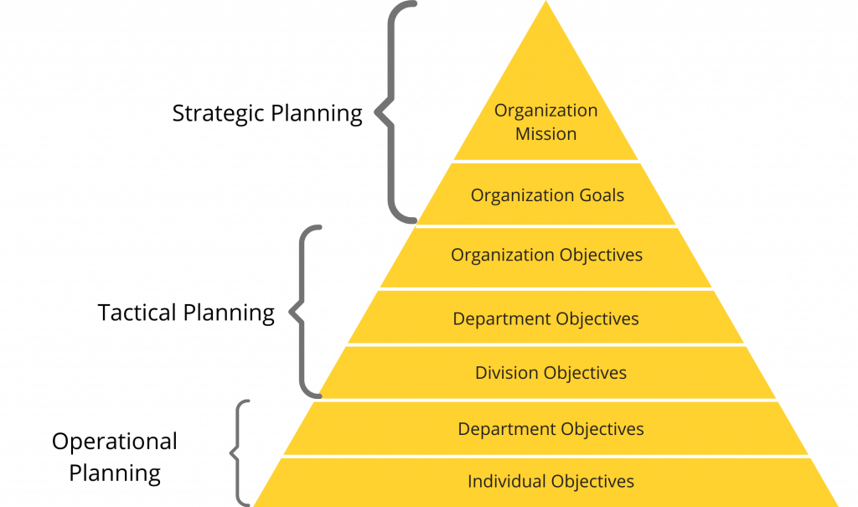

Planning is the map of success for the organization. So every organization needs a good planning process to achieve its goals and objectives. Some characteristics of a good plan are as follows.​

It should include **clear, well-defined goals and objectives.**​

The plan should be **simple** and **exhaustive**.​

**Well balanced** and **flexibility**​

**Time-bound**​

**Practicability**​

It should be an **economical** plan for the organization.​

The plan should be **suitable** for the organization.​

​

In a corporate structure, the levels of planning can be related to different functional areas and [levels of management](https://ceopedia.org/index.php/Levels_of_management" \t "https://euc-powerpoint.officeapps.live.com/pods/_blank). These can include:​

**Corporate-level planning**: This involves setting overall strategic goals and objectives for the entire organization, and determining the best course of action to achieve them.​

**Business-unit level planning**: This involves developing specific plans and actions for individual business units or divisions within the organization to implement the corporate-level strategic goals.​

**Functional-level planning**: This involves developing plans and actions for individual functional areas within the organization, such as finance, [marketing](https://ceopedia.org/index.php/Marketing" \t "https://euc-powerpoint.officeapps.live.com/pods/_blank), or operations, to support the business-unit level goals.​

**Operational-level planning**: This involves the day-to-day management and execution of plans and actions to achieve the functional and business-unit level goals.​

**Contingency and emergency planning**: This involves developing plans and procedures to respond to unexpected events or emergencies that could disrupt operations, both at the corporate and functional levels.​

The levels of planning can also be related to different time horizons, such as:

**Long-term planning**: This involves setting goals and objectives for a time horizon of several years or more, and determining the best course of action to achieve them.​

**Medium-term planning**: This involves developing specific plans and actions for a time horizon of one to three years to implement the long-term goals.​

**Short-term planning**: This involves developing specific plans and actions for a time horizon of one year or less to implement the medium-term goals.​

**Operational planning**: This involves the day-to-day management and execution of plans and actions to achieve the short-term goals.​

**Contingency and emergency planning**: This involves developing plans and procedures to respond to unexpected events or emergencies that could disrupt operations, regardless of the time horizon.​

**Corporate-level plans**: These plans set the overall [strategic direction](https://ceopedia.org/index.php/Strategic_direction" \t "https://euc-powerpoint.officeapps.live.com/pods/_blank) and goals for the entire organization, and may include a corporate mission statement, vision, values, and long-term [strategic objectives](https://ceopedia.org/index.php/Strategic_objectives" \t "https://euc-powerpoint.officeapps.live.com/pods/_blank).​

**Business-unit level plans**: These plans provide specific strategic direction and goals for individual business units or divisions within the organization, such as [product](https://ceopedia.org/index.php/Product" \t "https://euc-powerpoint.officeapps.live.com/pods/_blank) lines, [customer](https://ceopedia.org/index.php/Customer" \t "https://euc-powerpoint.officeapps.live.com/pods/_blank) segments, or geographic regions.​

**Functional-level plans**: These plans provide specific direction and goals for individual functional areas within the organization, such as finance, marketing, or operations.​

**Operational plans**: These plans describe the day-to-day activities and processes that will be used to achieve the strategic, business-unit, and functional-level goals.​

**Contingency and emergency plans**: These plans provide procedures and protocols for dealing with unexpected events or emergencies that may disrupt the normal operations of the organization.​

**Project plans**: These plans provide specific steps and actions to achieve specific goals within a specific time frame, usually for a one-time project or a specific initiative.​

​

Stages of planning

**1. Setting organizational objectives:**​

Planning is total based on the objectives, which an organisation wants to achieve by way of planning. In other words first of all objectives will be fixed and then we will make plan regarding how to gets success in achievement of such predetermine objective. ​

While making plan and setting objectives management should make analysis of internal resources available with the business and arrangement of external resources, external environments and corrective measures to face with the environment.​

**2. List of alternatives to achieve the objective:** there may be so many ways available with the business to achieve the objective. So business should prepare a list of such ways by considering the merits and demerits of each for which ever is better should be adopted. ​

​

**E.g.** target of increasing profitability may be achieved by increasing sale, decreasing cost, introducing new product of better technology, rise in process etc. which of these alternatives is beneficial for business be adopted. ​

Considering the merits and demerits of each alternative is also termed as development of premises of each alternative.​

**3. Choose the best alternative:** after considering the list of alternatives and merits of each management has to decide which of these alternatives will be the best in consideration with the human and nonhuman resources available with the business.​

**4. Formulation of supporting plans:** supporting plans are those plans, which provides support to the main plan. **E.g.**if the business wants to produce according to objective there may be many supporting plans like planning of purchase of raw material, planning of recruitment and training of the man power etc.​

**5. Put the plans into action:** after that plan formulated is ready to be put into action and so function should be started according to the plan all supporting plans should effort to help the main plan in reaching the objective and so in this all process is done in any effective manner we will get desired results of the plan.​

**6. Follow up:** once the plan is put into action it monitoring/supervision is equally important. In the main time management should see whether we are going towards achievement of objective or not. There may be some changes required before reaching the objective. **E.g.** a company is to sell 1200 refrigerators per year than directors should see that at least 100 units per month on average basis should be sold to achieve the target.​

Co-ordination is the unification, integration, synchronization of the efforts of group members so as to provide unity of action in the pursuit of common goals. ​

According to *Mooney and Reelay*, “**Co-ordination is orderly arrangement of group efforts to provide unity of action in the pursuit of common goals**”.​

According to *Charles Worth*, “Co-ordination is the integration of several parts into an orderly whole to achieve the purpose of understanding”.​

Co-ordination is an orderly arrangement of efforts to provide unity of action in the fulfillment of common objective whereas co-operation denotes collective efforts of persons working in an enterprise voluntarily for the achievement of a particular purpose. It is the willingness of individuals to help each other.​

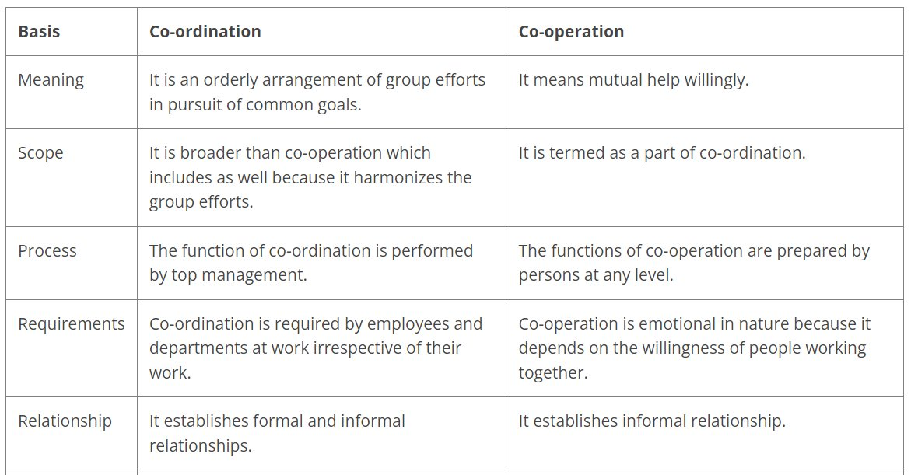

**Types of control**​

​

There are three types of control viz.,​

**Feedback Control**: This process involves collecting information about a finished task, assessing that information and improvising the same type of tasks in the future.

**Concurrent control**: It is also called real-time control. It checks any problem and examines it to take action before any loss is incurred. Example: control chart.

**Predictive/ feedforward control**: This type of control helps to foresee problem ahead of occurrence. Therefore, action can be taken before such a circumstance arises.​

Planning precedes controlling and controlling succeeds planning.​

Planning and controlling are inseparable functions of management.​

Activities are put on rails by planning and they are kept at right place through controlling.​

The process of planning and controlling works on Systems Approach which is as follows : **Planning    →    Results    →    Corrective Action**​

​

Stuffing

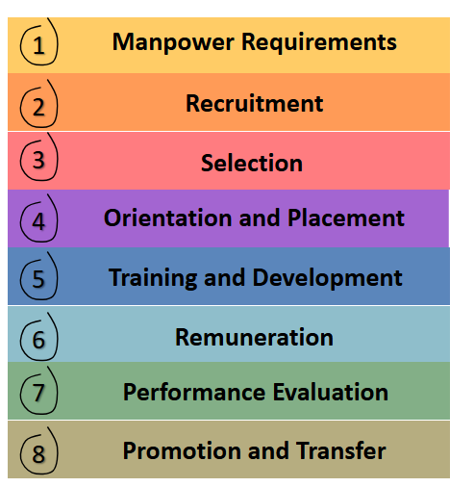

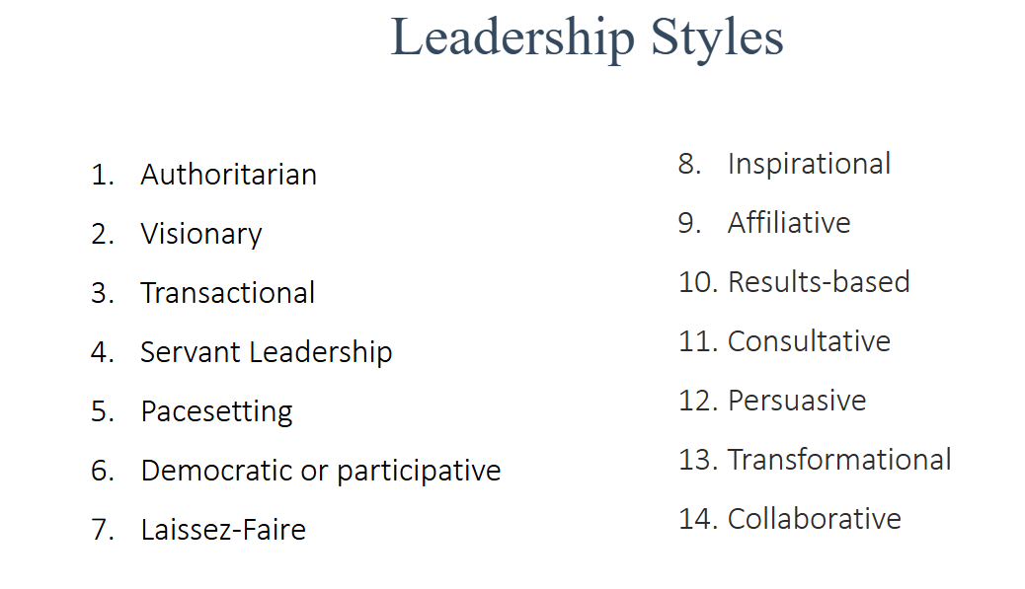

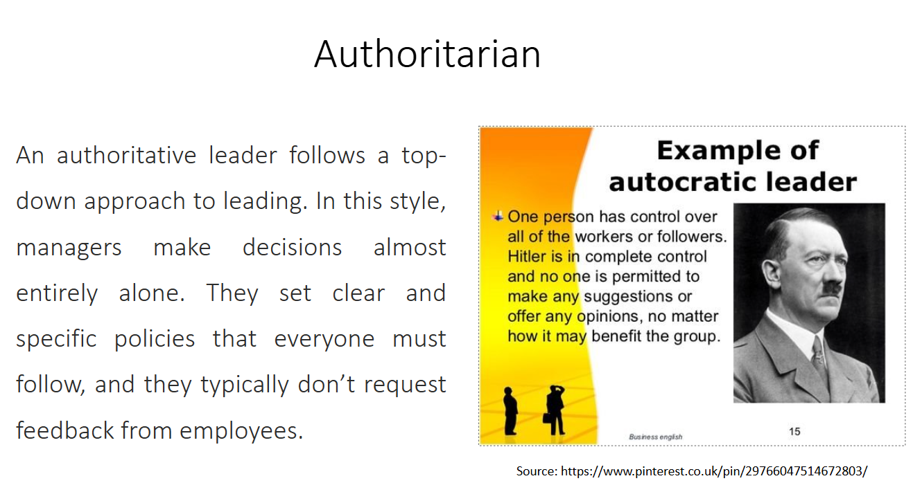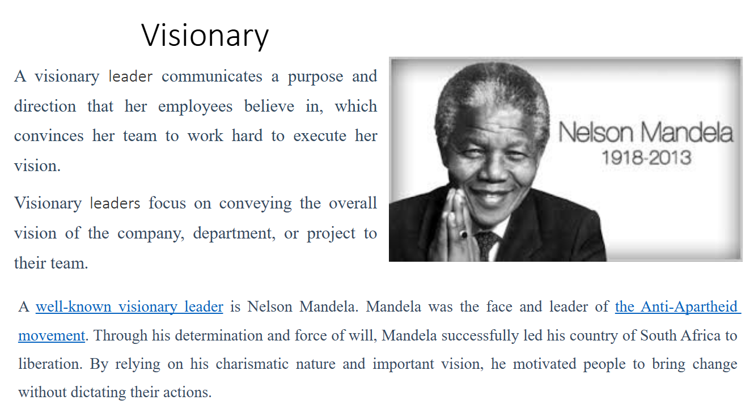

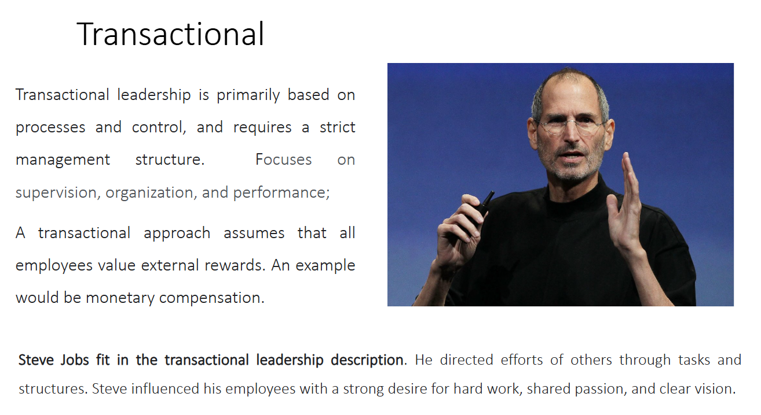

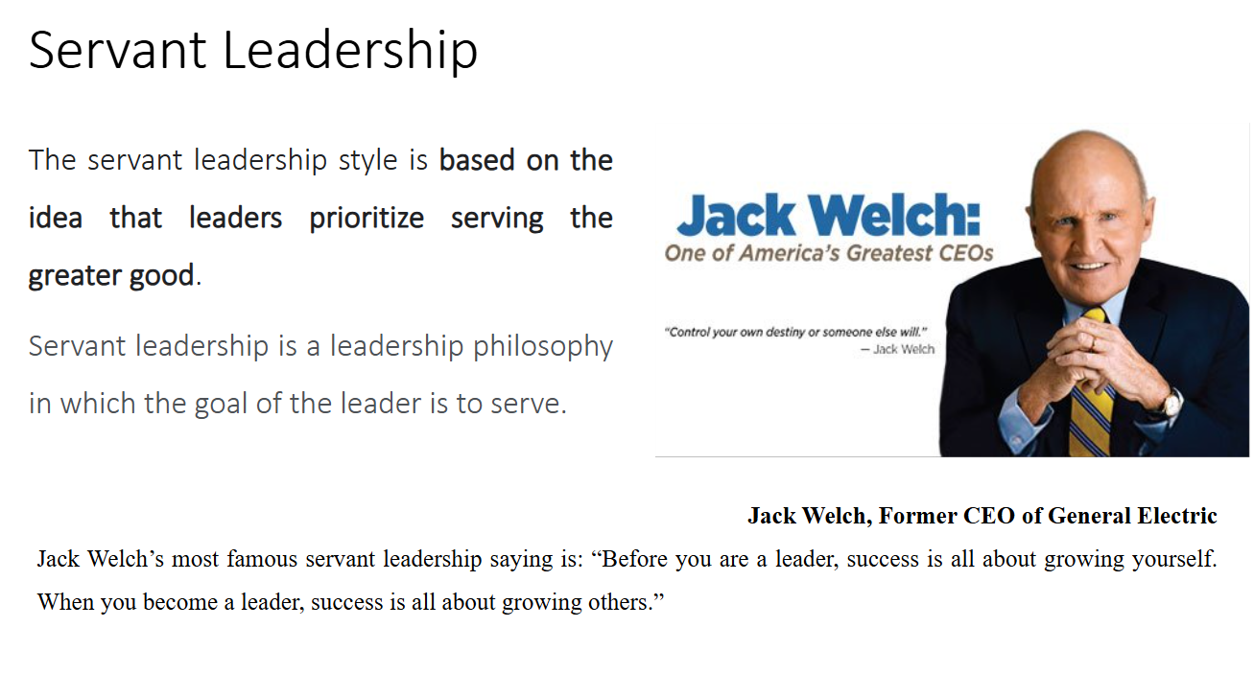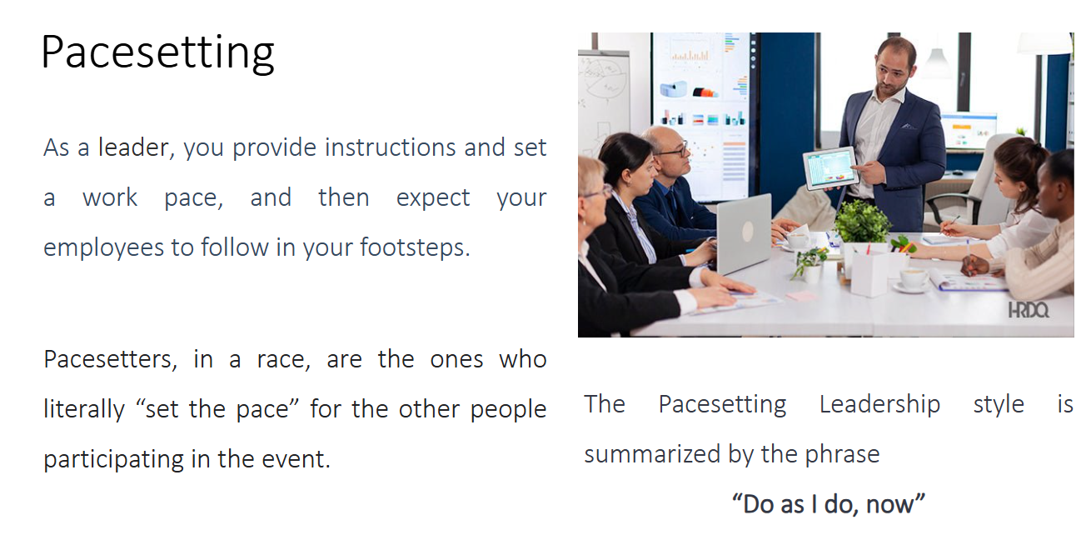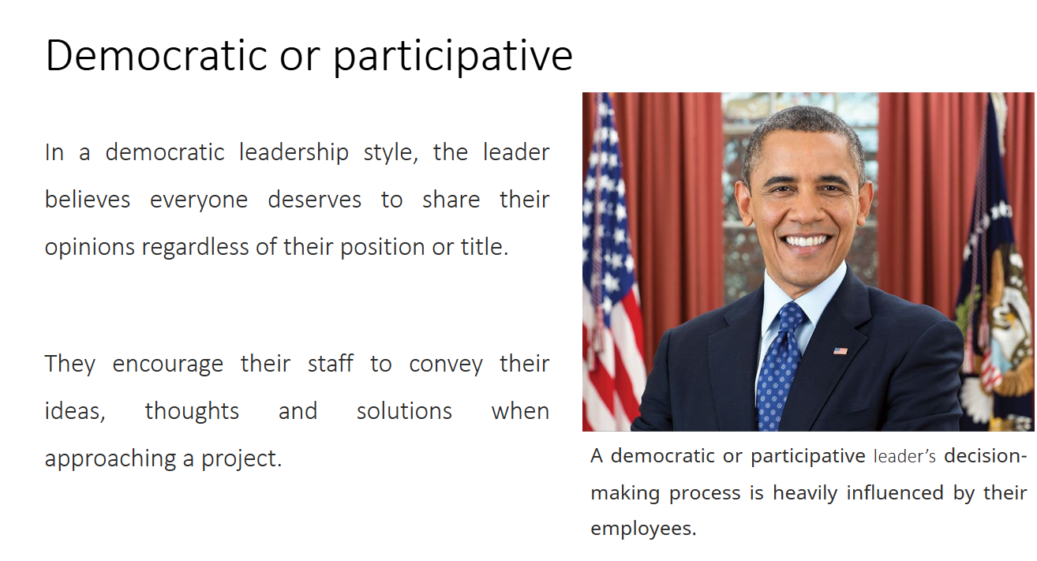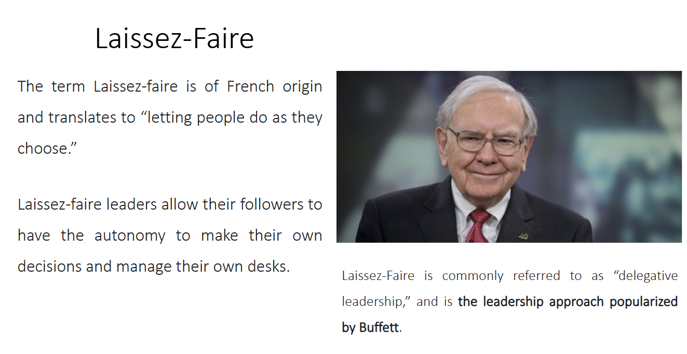

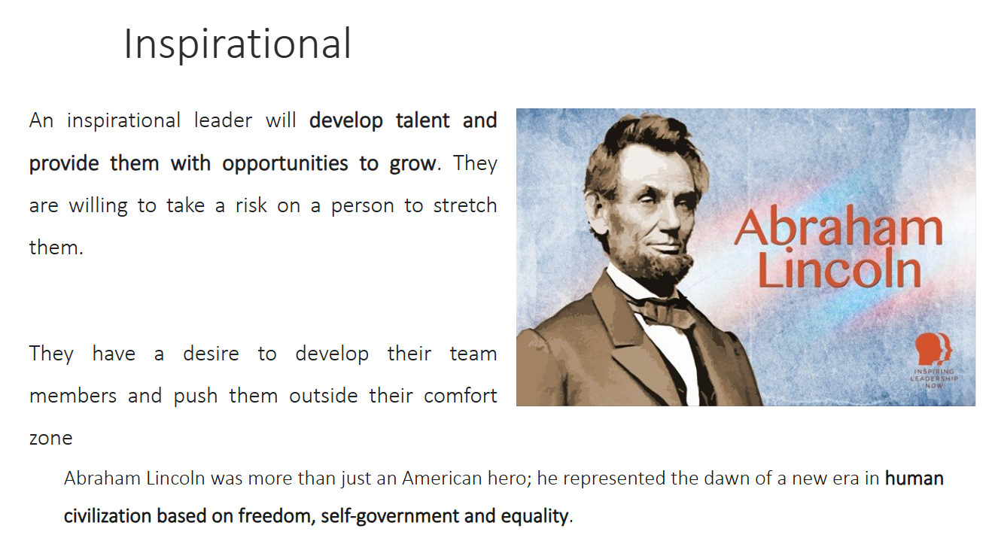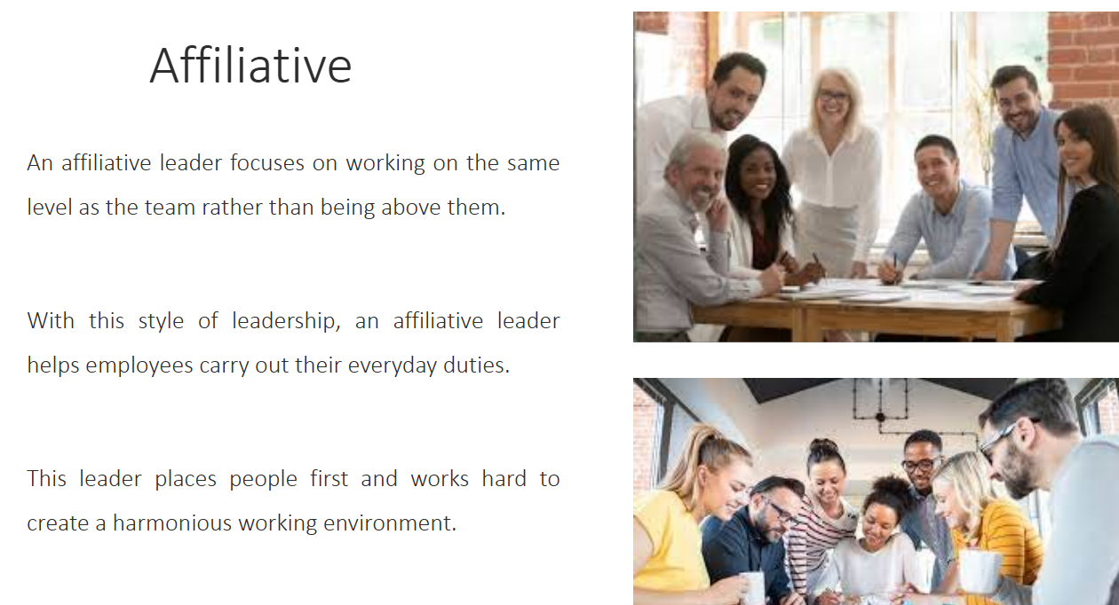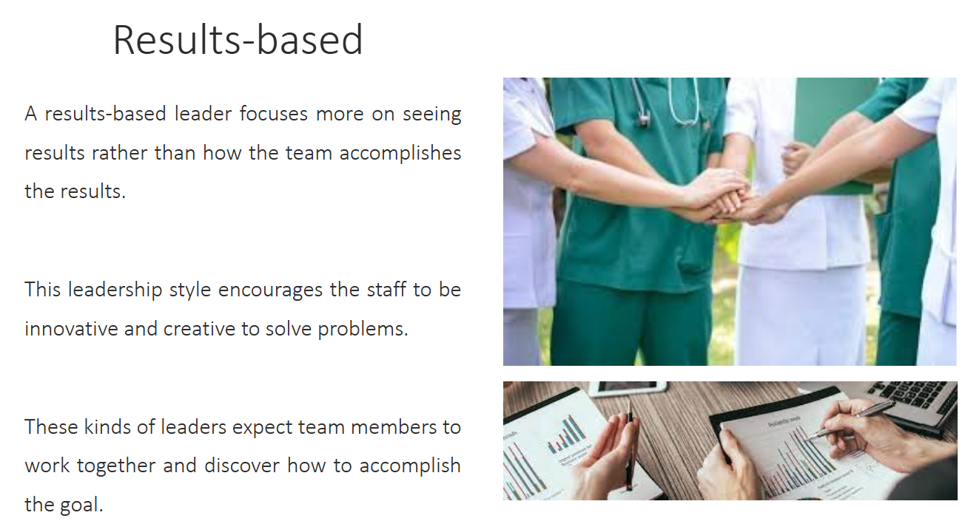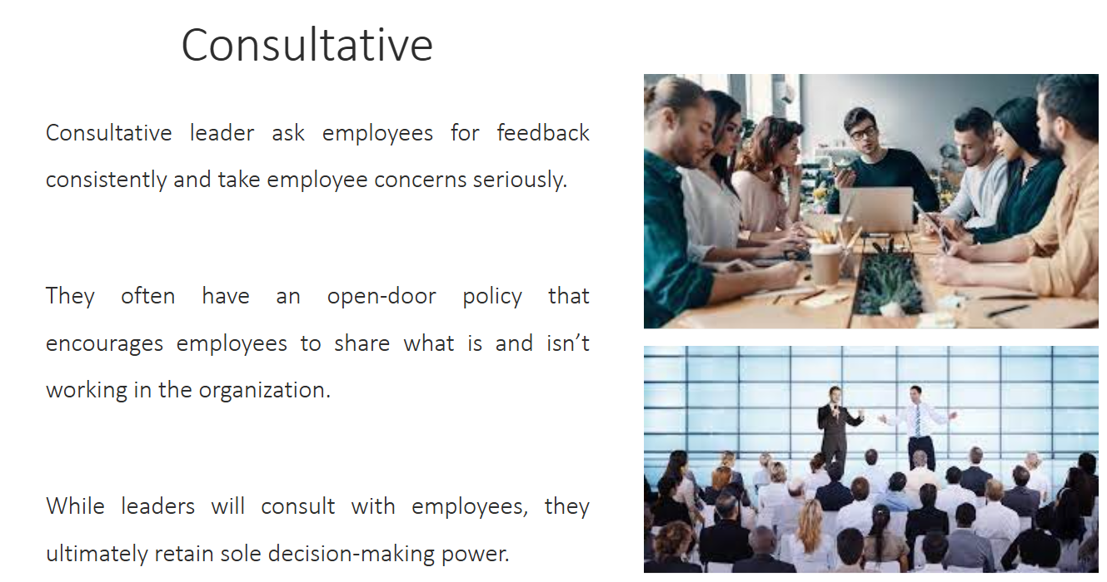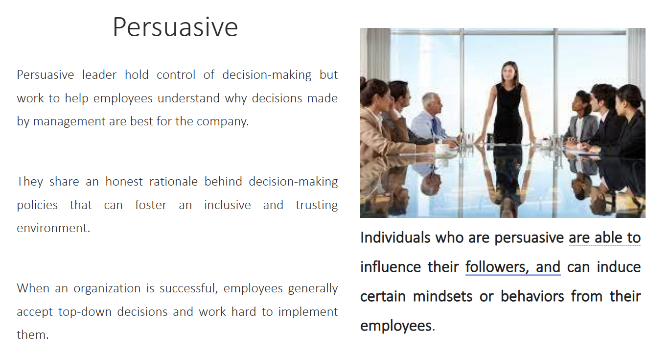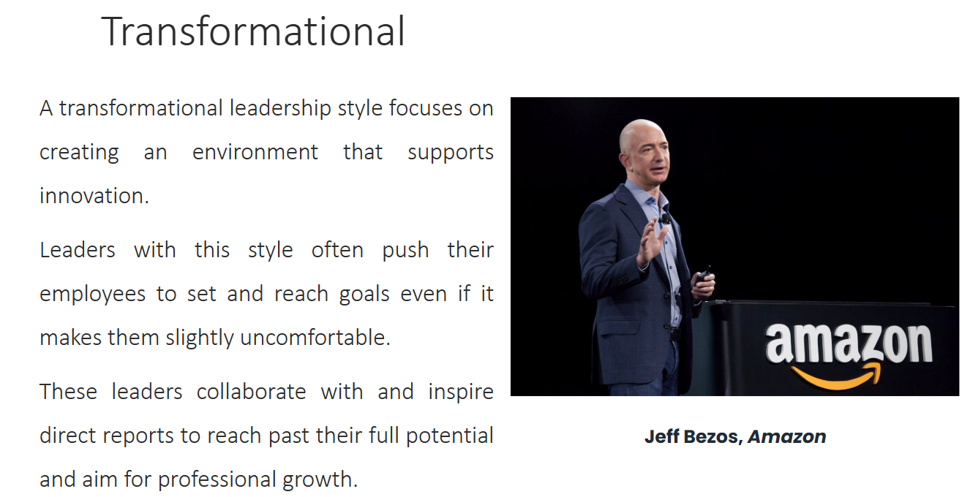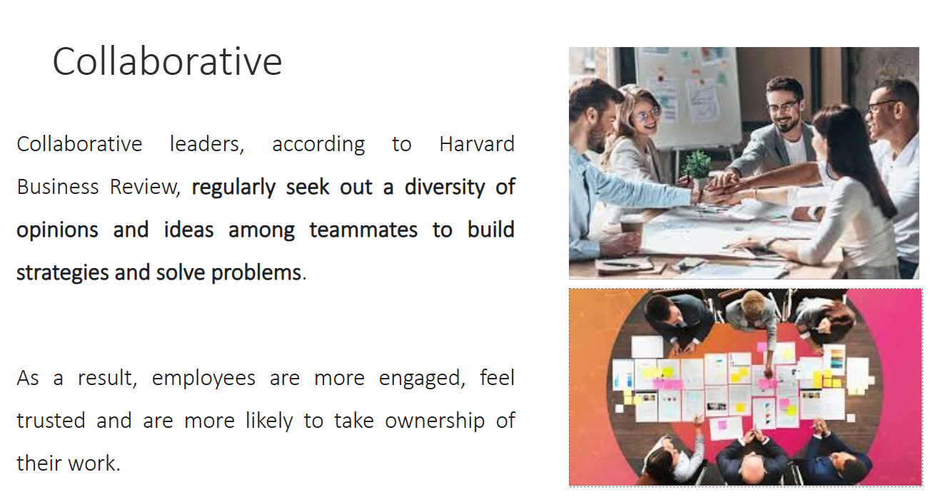

Communication is significant for managers in an organizations so as to perform the basic functions of management, i.e., Planning, Organizing, Leading and Controlling. Communication helps managers to perform their jobs and responsibilities.​

​

Managerial communication is a function which helps managers communicate with each other as well as with the other employees of an organization.​

​

Business Communication is goal oriented. Earlier, business communication was limited to paper-work, telephone calls etc. But now we have cell phones, video conferencing, emails, satellite communication etc.​

**Communication** is a process of exchanging verbal and non verbal messages. The main components of communication process are - Context, Sender, Message, Medium, Recipient and Feedback​

**Oral communication** implies communication through mouth. It includes individuals conversing with each other, be it direct conversation or telephonic conversation. Speeches, presentations, discussions are all forms of oral communication.​

**Written communication** has great significance in todays business world. Effective written communication is essential for preparing worthy promotional materials for business development.​

**Non Verbal Communication** is communication of feelings, emotions, attitudes, and thoughts through body movements/gestures/eye contact, etc.​

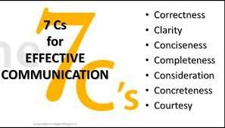

**Completeness -** The communication must be complete. It should convey all facts required by the audience.​

​

**Conciseness -** Conciseness means wordiness, i.e, communicating what you want to convey in least possible words without forgoing the other C’s of communication.​

**Consideration -** Consideration implies “stepping into the shoes of others”. Effective communication must take the audience into consideration, i.e, the audience’s view points, background, mind-set, education level, etc. ​​

​

**Clarity -** Clarity implies emphasizing on a specific message or goal at a time, rather than trying to achieve too much at once.​

​

**Concreteness -** Concrete communication implies being particular and clear rather than fuzzy and general. Concreteness strengthens the confidence. ​

​

**Courtesy -** Courtesy in message implies the message should show the sender’s expression as well as should respect the receiver. The sender of the message should be sincerely polite, judicious, reflective and enthusiastic.​

​

**Correctness -** Correctness in communication implies that there are no grammatical errors in communication.​

**There are 8 steps of Decision Making:**​

Identification of problem•​

Identification of decision Criteria•​

Allocating weight to criteria• ​

Develop alternatives• ​

Analysis of Alternatives• ​

Selection of alternatives•​

Implementation of the best alternatives•​

Evaluation of decision effectiveness​

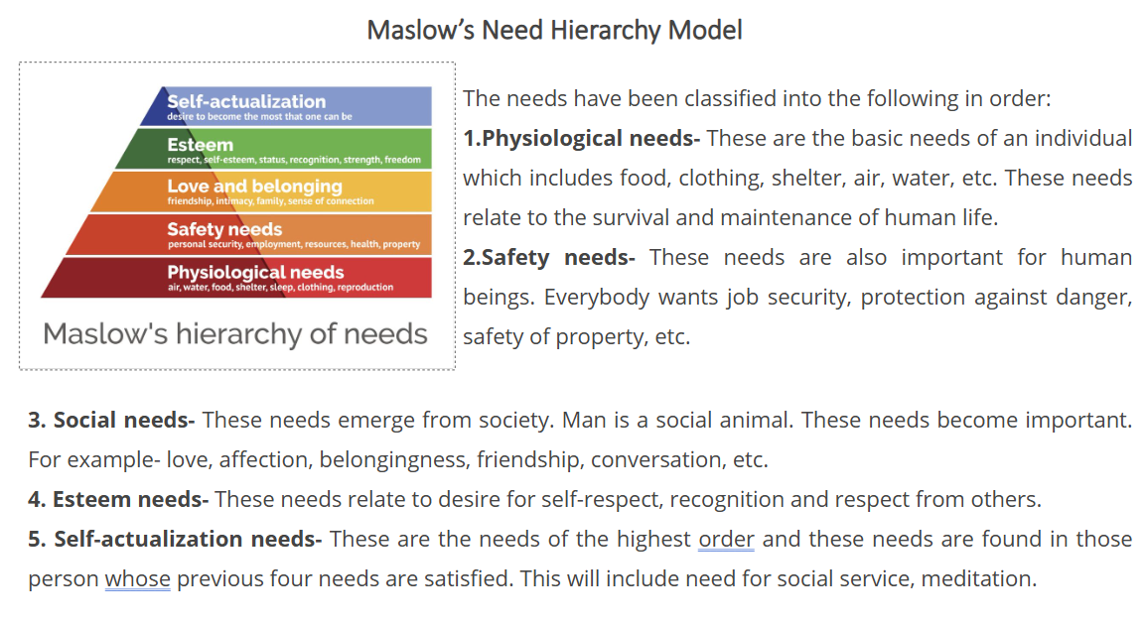

**We live in VUCA World** ​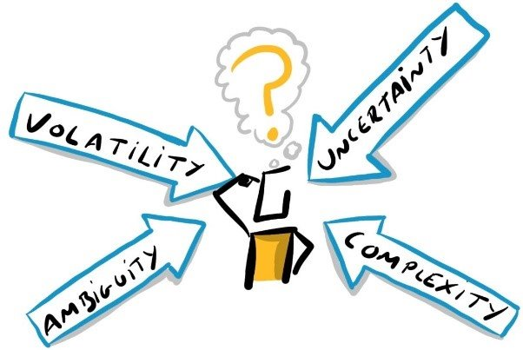

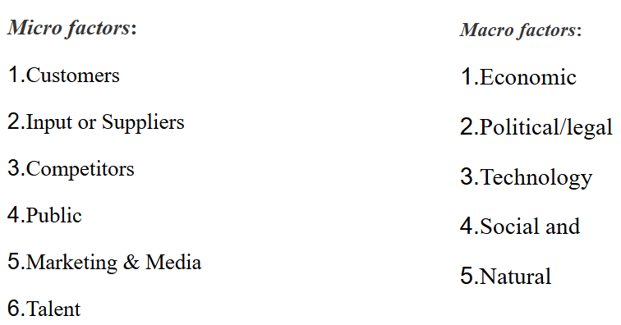

By definition, business ethics are the moral principles that act as guidelines for the way a business conducts itself and its [transactions](https://corporatefinanceinstitute.com/resources/templates/transactions/" \t "https://euc-powerpoint.officeapps.live.com/pods/_blank). ​

​

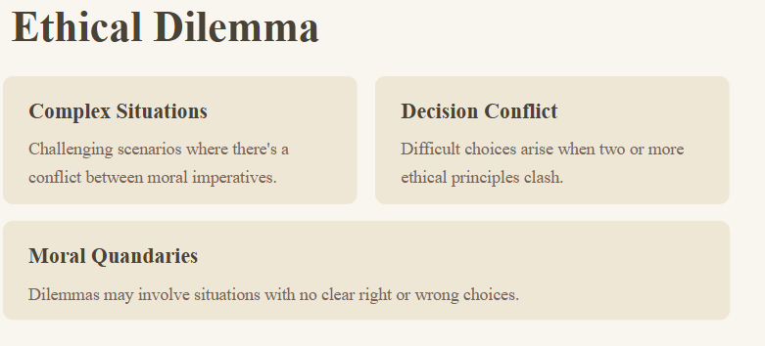

Corporate Social Responsibility is a management concept whereby companies integrate social and environmental concerns in their business operations and interactions with their stakeholders.​

Corporate social responsibility, or CSR, is a form of self-regulation that reflects a business’s accountability and commitment to contributing to the well-being of communities and society through various environmental and social measures. ​

CSR plays a crucial role in a company’s brand perception; attractiveness to customers, employees, and investors; talent retention; and overall business success. ​

A company can implement four types of CSR efforts: environmental initiatives, charity work, ethical labor practices and volunteer projects. ​

​

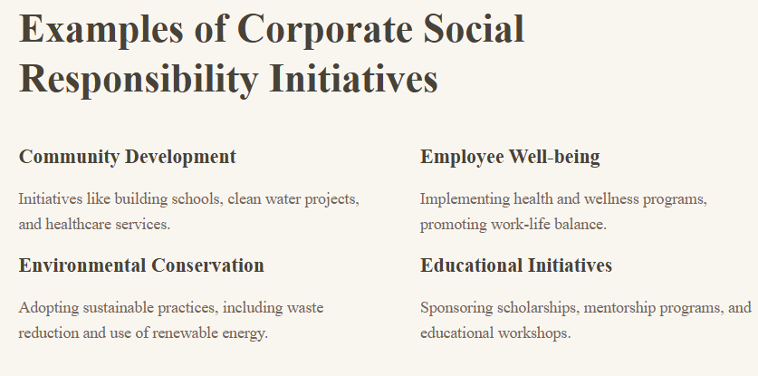

Conflicts

Intrapersonal - taking place or existing within the mind.​

Interpersonal - taking place or existing between persons​

Intragroup -  occurring within an institution or community.​

Intergroup - existing or occurring between two or more social groups​

**What are 5 ways to resolve conflict?**​

To avoid or resolve conflicts that could negatively influence your company's productivity, follow these steps to help find an agreeable solution:​

Acknowledge the conflict. ...​

Define the problem. ...​

Meet on neutral ground. ...​

Let everyone have a say. ...​

Agree on a solution. ...​

Determine each side's role in the solution.​

**Power** can be defined as an interpersonal relationship in which one individual (or group) has the ability to cause another individual (or group) to take an action that would not be taken otherwise.​

​

Power involves one person changing the behavior of another. That is, person A has power over person B if person B believes that person A can, in fact, force person B to comply.​

​

**Legitimate power** is power that comes from one’s organizational role or position.​

​

**Reward power** is the ability to grant a reward, such as an increase in pay, a perk, or an attractive job assignment. ​

​

**Coercive power** is the ability to take something away or punish someone for noncompliance. ​

​

**Expert power** comes from knowledge and skill. Examples of expert power can be seen in staff specialists in organizations (e.g., accountants, labor relations managers, management consultants, and corporate attorneys).​

​

**Information power** is similar to expert power but differs in its source. Individuals who are able to span boundaries and serve to connect different parts of the organizations often have a great deal of information power.​

​

**Referent power** stems from the personal characteristics of the person such as the degree to which we like, respect, and want to be like them.​

The term ‘organizational politics’, also known as workplace politics or office politics, refers to the agenda of each employee within a company and the activities they engage in to acquire, increase, and wield power and resources to gain a desired outcome.

Creativity is the ability to think about a task or a problem in a new or different way, or the ability to use the imagination to generate new ideas. ​

​

**Creativity is the ability to transcend traditional ways of thinking or acting, and to develop new and original ideas, methods or objects.**​

A new idea, method, or device ; the introduction of something new.​

​

Business innovation is when companies implement new processes, ideas, services, or products with the goal of boosting the bottom line.​

​

Innovation is a product, service, business model, or strategy that's both novel and useful. Innovations don't have to be major breakthroughs in technology or new business models; they can be as simple as upgrades to a company's customer service or features added to an existing product.​

**Creativity** involves generating original and unique ideas, while **innovation** is about implementing those ideas to create value. Understanding these distinctions is essential for organizations and individuals looking to remain competitive in their respective fields.​

Entrepreneurship is the ability and readiness to develop, organize and run a business enterprise, along with any of its uncertainties in order to make a profit. The most prominent example of entrepreneurship is the starting of new businesses.​

​

Entrepreneurship is frequently credited as a major driver of economic growth, spurring transformation, the creation of new markets, innovation, and building wealth. Entrepreneurs are often key to developing ideas and solutions to problems while creating new products.​